H.T No
Regulations:
A18

Sreenidhi Institute of Science and Technology
(An Autonomous Institution)
Code No: 7B310 Date: 06-Oct-2020 (FN)

B.Tech II-Year I-Semester External Examination, October - 2020 (Supplementary)
MACHINE DRAWING AND COMPUTER AIDED DRAWING PRACTICE (ME)

Time: 2 Hours Max.Marks:70

Note: a) No additional answer sheets will be provided.
b) All sub-parts of a question must be answered at one place only, otherwise it will not be valued.
c) Missing data can be assumed suitably.

ANSWER ALL TWO QUESTIONS.

1. | a) | Sketch the following thread profiles for a nominal diameter of 25 mm and pitch 3 mm and give their applications:  - BSW thread,  - Buttress thread  - Square thread,  - ACME thread and  - Worm thread. | [30M]
 |  | (OR)
 | b) | Draw a double riveted lap joint with zigzag riveting. Take plate thickness as 16mm. | [30M]
2. |  | Assemble all parts of the stuffing box, as shown in Fig.1 and draw:  Half sectional front view.  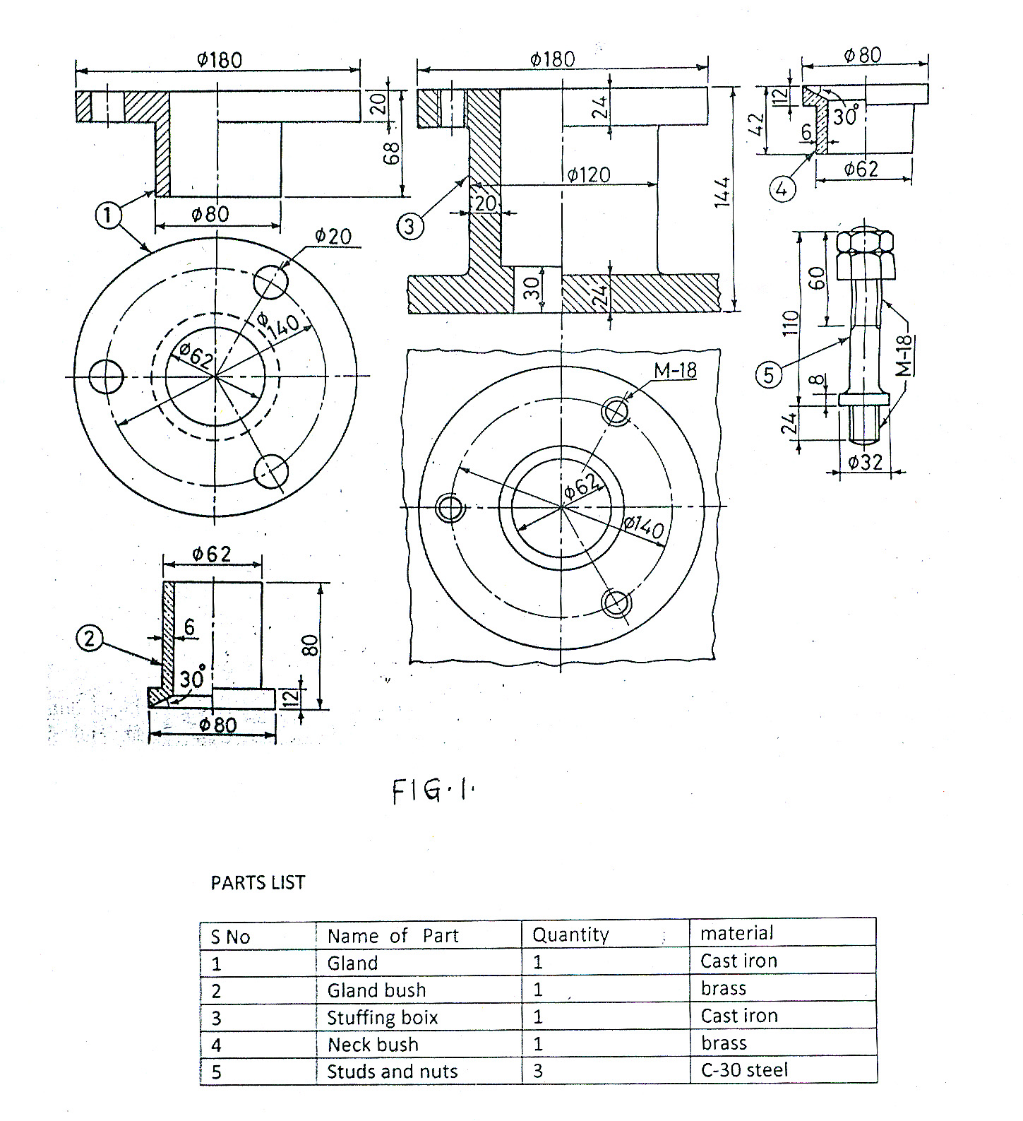 | [40M]

-- 00 -- 00 –

